Spectral Overdrive Pulse Drive
Proof-of-Concept White Paper
Speculative propulsion architecture for pulsed magnetoplasma thrust, vector control, and rotational field shaping

System Name | Spectral Overdrive Pulse Drive (SOPD)
Concept Role | Pulsed magnetoplasma propulsion and vectoring core
Document Type | Concept white paper / bench-scale proof of concept

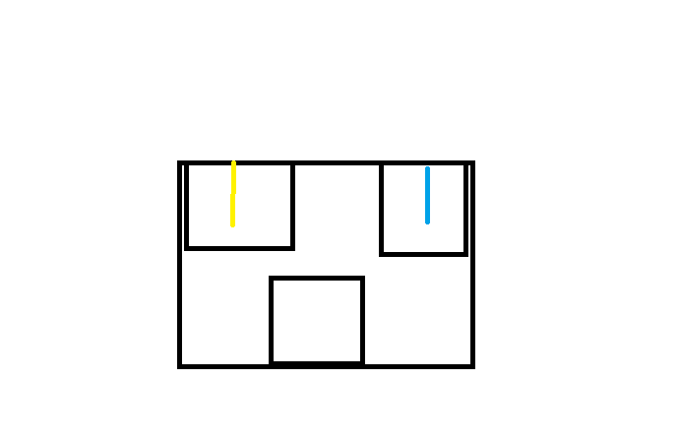
Figure 1. User concept sketch showing upper overdrive cell and lower PTEC-style field element.

Abstract
This paper proposes the Spectral Overdrive Pulse Drive (SOPD), a speculative propulsion module that couples an upper spectral overdrive cell with a lower rotational magnetic core. In this architecture, the upper cell energizes and ionizes a working plasma while the lower core shapes that plasma with rotating magnetic fields, compresses it, and releases it in timed pulse packets. The result is framed not as reactionless motion, but as a pulse-modulated magnetoplasma drive concept intended for vectored impulse bursts, attitude control, and stabilized directional thrust.

1. Concept Thesis
The core premise is that a two-layer stack can perform better than a single continuous discharge device. The upper cell handles plasma generation and electrical excitation. The lower PTEC-like stage supplies rotational magnetic geometry, allowing the energized plasma to be spun, compressed, and released in pulses rather than as a steady dump.
In engineering terms, the concept becomes: energize, confine, spin, pulse, and eject. This improves the clarity of the architecture by giving separate jobs to separate layers.

2. Architectural Stack
Layer | Element | Primary Function | Notes
Top | Spectral Overdrive Cell | Ionization and electrical excitation | Creates and conditions working plasma for downstream shaping
Middle | Transfer / throat region | Channels energized plasma | Couples electrical discharge output into the magnetic core
Bottom | Rotational magnetic core (PTEC-style) | Field shaping and pulse compression | Generates rotating magnetic geometry and directional bias
Output | Pulse nozzle / vector manifold | Impulse release | Releases pulsed magnetoplasma exhaust or redirected packets

3. Operating Principle
Stage A — Plasma Preparation: The overdrive cell ionizes and electrically excites the chosen working medium, creating a controllable plasma source.
Stage B — Rotational Field Capture: The lower core imposes a rotating magnetic field, confining the plasma column and inducing angular structure before release.
Stage C — Pulse Compression: Magnetic timing compresses the energized column into discrete impulse packets rather than a single continuous plume.
Stage D — Vector Release: Pulse packets are ejected or redirected through a manifold, generating thrust, stabilization, or attitude-correction behavior depending on timing and geometry.

4. Why the Rotational Magnetic Core Matters
A rotating magnetic field stage gives the concept its strongest internal logic. Instead of merely dumping ionized material, the system can spin the plasma column, improve directional coherence, suppress random plume instability, and create repeatable harmonics in the exhaust.
Design shorthand: plasma out is crude; spin, compress, pulse, release is architecture.

5. Potential Operating Modes
Mode | Pulse Pattern | Intended Use | Expected Behavior
Hover Trim | Low amplitude, high frequency | Fine stabilization | Small corrective impulse packets
Cruise Thrust | Moderate amplitude, phased bursts | Main forward motion | Sustained pulse-modulated propulsion
Torque Bias | Asymmetric timing | Attitude control | Rotational correction without full gimbal movement
Burst Mode | High amplitude, short duration | Rapid maneuvering | Brief impulse spikes with thermal penalty

6. Physics Boundary
The concept remains bounded by conservation of momentum. Rotating magnetic fields and internal pulses alone do not create net motion. The drive only functions as propulsion when momentum is exchanged through expelled plasma, directed electromagnetic emission, or coupling to an external medium or field.
Accordingly, the SOPD should be described as a pulsed magnetoplasma propulsion concept, not as a reactionless drive.

7. Bench-Scale Proof of Concept Path
Phase | Test Goal | Instrumentation | Success Signal
I | Verify stable plasma generation in upper cell | Current probes, spectroscopy, thermal imaging | Repeatable plasma ignition without uncontrolled flare
II | Validate rotating field capture in lower core | Magnetic probes, high-speed video | Observable confinement and spin behavior
III | Test pulsed release timing | Fast current logging, plume imaging | Discrete impulse packets rather than continuous discharge
IV | Measure vector response | Micro-thrust stand or surrogate flow rig | Directional bias and measurable pulse asymmetry

8. Measurement Targets
- Plasma ignition stability and repeatability
- Rotational field coherence across the lower core
- Pulse frequency, duty cycle, and timing precision
- Plume stability and vector bias under phase changes
- Heat load, coil stress, and switching losses

9. Risks and Failure Modes
- Thermal overload in the overdrive cell during burst operation
- Field collapse or plume instability during phase mismatch
- Switching losses and coil heating in the rotational core
- Unwanted internal torque if release timing is not balanced
- Low net efficiency if the pulse architecture adds complexity without improving exhaust quality

10. Conclusion
The Spectral Overdrive Pulse Drive is a coherent speculative propulsion architecture when framed as a two-stage pulsed magnetoplasma system. The upper spectral overdrive cell generates and excites the working plasma. The lower PTEC-style core shapes that plasma with rotating magnetic fields and converts continuous energy into controlled pulse release. Its most plausible role is not miracle propulsion, but vectored impulse generation, stabilization, and pulse-managed thrust in a compact conceptual package.

